

**《面向对象的程序设计》**

**大作业**

**题目：** 房贷计算器 s

物联网工程学院 **学院** 计算机科学与技术 **专业**

学 号： 1033190212 j

学生姓名： 苏乐德 j

班 级： 计算机科学与技术1902 k

成 绩： j

**2020年 6月 19 日**

Table of Contents

1

1. Introduction 3

1.1 Goals and Requirements 3

1.2 Scope 3

1.3 References 3

1.4 Overview 3

1.5 Discussion of User Interface Design 4

1.5.1 Calculator.net mortgage calculator 4

1.5.2 Zillow Mortgage Calculator 5

1.6 User Interface Design 5

2. Use-case View 6

2.1 Use Case Model Overview 6

3. Logical View 8

3.1 Classes 8

3.1.1 calculator 8

4. Size and Performance 10

# Introduction

## Goals and Requirements

This document addresses the following goals and functional requirements for designing a house mortgage calculator.

* Calculate payment of fixed-payment mortgage payment.
* Calculate payment of fixed-payment mortgage payment through combination method.
* Calculate payment of fixed-basis mortgage payment.
* Calculate payment of fixed-basis mortgage payment through combination method.

## Scope

This product will be used by individuals who need to calculate their house mortgage. The objective is to design a simple, intuitive interface and stable program for the calculation of house mortgage.

## References

[1] Mortgage loan URL:

[https://en.wikipedia.org/wiki/Mortgage_loan#Principal_and_interest]

[2] Calculator.net mortgage calculator URL:

[<https://www.calculator.net/mortgage-calculator.html>]

[3] Zillow mortgage calculator URL:

[<https://www.zillow.com/mortgage-calculator/>]

## Overview

This House mortgage calculator will be implemented in C++ using OOP (Object-oriented programming) concept. Its’ graphic design will be based on QT platform.

The most common way to repay a secured mortgage loan is to make regular payments toward the principal and interest over a set term (fixed-payment mortgage). An amortization schedule is typically worked out taking the principal left at the end of each month, multiplying by the monthly rate and then subtracting the monthly payment. This is typically generated by an amortization calculator using the following formula: [1]

$$A=P∙\frac{r{(1+r)}^{n}}{{(1+r)}^{n}-1}$$

where:

$A$ is the periodic amortization payment (monthly payment).

$P$ is the principal amount borrowed.

$r$ is the rate of interest expressed as a fraction; for a monthly payment, take the (Annual Rate)/12.

$n$ is the number of payments; for monthly payments over 30 years, 12 months x 30 years = 360 payments.

The main alternative to a principal and interest mortgage is fixed basis repayment method. Payment in each month is typically calculated through following formula:

$$A_{i}=\frac{P}{n}+(P-\frac{P}{n}∙\left(i-1\right))∙r$$

Where:

$A_{i}$ is the total payment in ith month.

$P$ is the principal amount borrowed.

$r$ is the rate of interest expressed as a fraction; for a monthly payment, take the (Annual Rate)/12.

$n$ is the number of payments.

## Discussion of User Interface Design

### Calculator.net mortgage calculator

Figure 1: Calculator.net mortgage calculator [3]

Calculator.net mortgage calculator (figure 1) features its intuitive, clean and elegant user interface with a variety of functions. Even though it has clean instructions for each option, if users are looking forward to calculate their payment, they have to input or select every single option and press the button to start calculation. But when users are trying to calculate another schedule for comparison, all of its’ data have to be erased and users have to fill them one by one again, which makes it hard to make direct comparison.

### Zillow Mortgage Calculator

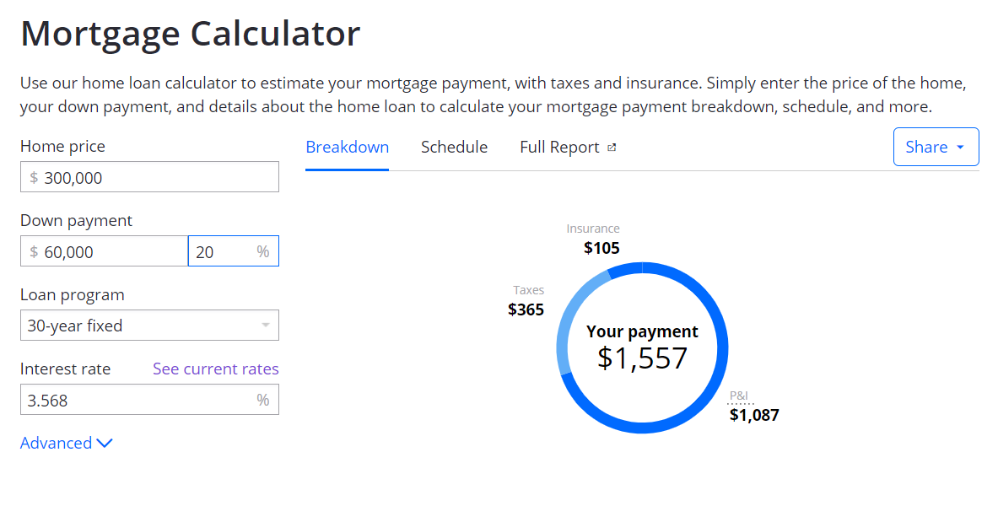

Figure 2: Zillow Mortgage Calculator [3]

Compared with Fang Tian Xia Mortgage calculator, Zillow Mortgage calculator (figure 2) has no button for submission. Whenever the user changes any of the value, it calculates and displays the result automatically. In this case, users will get quickly informed by variations of different types of schedule.

## User Interface Design



Figure 3: User interface 1

The user interface has two major parts. In the first part (Figure 3), it has an input box (QlineEdit) for total amount, two set of combination of spin box (QSpinBox) and slider (QSlider) for fine adjustment and quick adjustment. On the left side, there is a part of text displays its’ final calculation result, which is its’ payment in first month. Below is a simple chart illustrating the ratio of interest and principle. The whole page has no submit button. Every time the user edits the text or moves one of its’ slide bars or combo boxes, the result display will change with user’s movement.

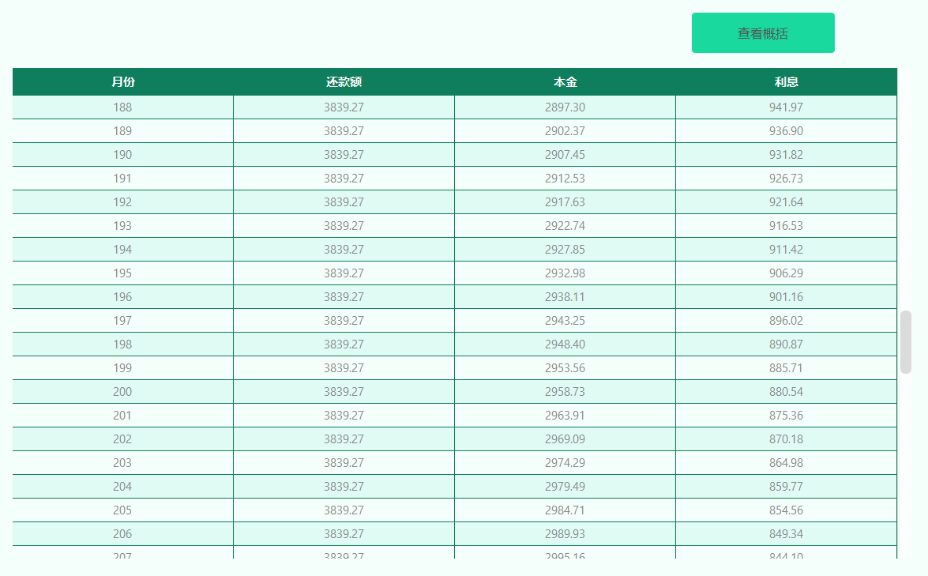

Figure : user interface 2

# Use-case View

## Use Case Model Overview



Figure 5: House Mortgage Calculator Use-Case Diagram



Figure 6: Calculate Activity Diagram

# Logical View

## Classes



Figure 7：Class Diagram

### calculator

* **Brief Description**

**This class is the main realization of calculating process. Related parameters can be set and it can return calculation result.**

* **Attributes**

|  |  |  |  |
| --- | --- | --- | --- |
| **Access** | **Type** | **Name** | **Description** |
| private | double | totalAmount | Total amount of loan |
| private | double | interestRate | Interest rate of loan |
| private | int | loanPeriod | length of loan |
| private | double | totalAmount_CM | Commercial part of total amount for combined repayment method |
| private | double | totalAmount_PF | Housing provident part of total amount for combined repayment method |
| private | double | interestRate_CM | interest rate of Commercial part for combined repayment method |
| private | double | interestRate_PF | interest rate of Housing provident part for combined repayment method |
| private | int | loanPeriod_2 | Length of loan for combined repayment method |
| private | int | repaymentMethod | Specifies current repayment method (fixed payment or fixed basis) |
| private | int | loanType | Specifies current loan type (general or combined) |
| private | QVector<eachMonth> | schedule | Full schedule for current loan |

* **Methods**

|  |  |  |  |  |
| --- | --- | --- | --- | --- |
| **Access** | **Return** | **Name** | **Params** | **Description** |
| private | double | paymentInFirstMonth_fixedPayment | Integer: i | Returns payment in first month of fixed payment repayment method |
| private | double | paymentInFirstMonth_fixedBasis | Integer: i | Returns payment in first month of fixed basis repayment method |
| public | void | setTotalAmount | Double: TotalAmount | Setter of total amount |
| public | void | setRepaymentMethod | Integer: method | Setter of repaymentMethod |
| public | void | setloanType | Integer: type | Setter of loanType |
| public | void | setInterestRate | Integer: rate | Setter of interestMate |
| public | void | setLoanPeriod | Integer: period | Setter of LoanPeriod |
| public | void | setInterestRate_CM | Double: i | Setter of interestRate_CM |
| public | void | setInterestRate_PF | Double: i | Setter of interestRate_PF |
| public | void | setHomePrice_CM | Double: i | Setter of homePrice_CM |
| public | void | setHomePrice_PF | Double: i | Setter of homePrice_PF |
| public | void | setLoanPeriod_2 | Integer: i | Setter of loanPeriod_2 |
| public | int | getLoantype | None | Getter of loanType |
| public | int | getRepaymentMethod | None | Getter of repaymentMethod |
| public | int | getLoanPeriod | None | Getter of loanPeroiod |
| public | int | getLoanPeriod_2 | None | Getter of loanPeriod_2 |
| public | double | getProportion_interest1 | None | A method returns proportion of interest of general loan type |
| public | double | getProportion_interest2 | None | A method returns proportion of interest of combined loan type |
| public | eachMonth | getTableValue | Integer: i | A method returns schedule of i+1 th month |
| public | void | calculateTableValue | None | A method refreshes Full schedule stored in QVecrtor schedule |
| public | double | refreshDisplay_line | None | A method returns value of payment in first month or monthly payment |
| public | double | refreshDisplay_line2 | None | A method returns value of payment in first month or monthly payment for combined loantype |

# Size and Performance

* The House mortgage calculator will perform all functions with minimal delay.
* For the full report page, it will refresh it’s data after user stop adjusting relevant parameters and press “view full report” button so that unnecessary calculations can be avoided.